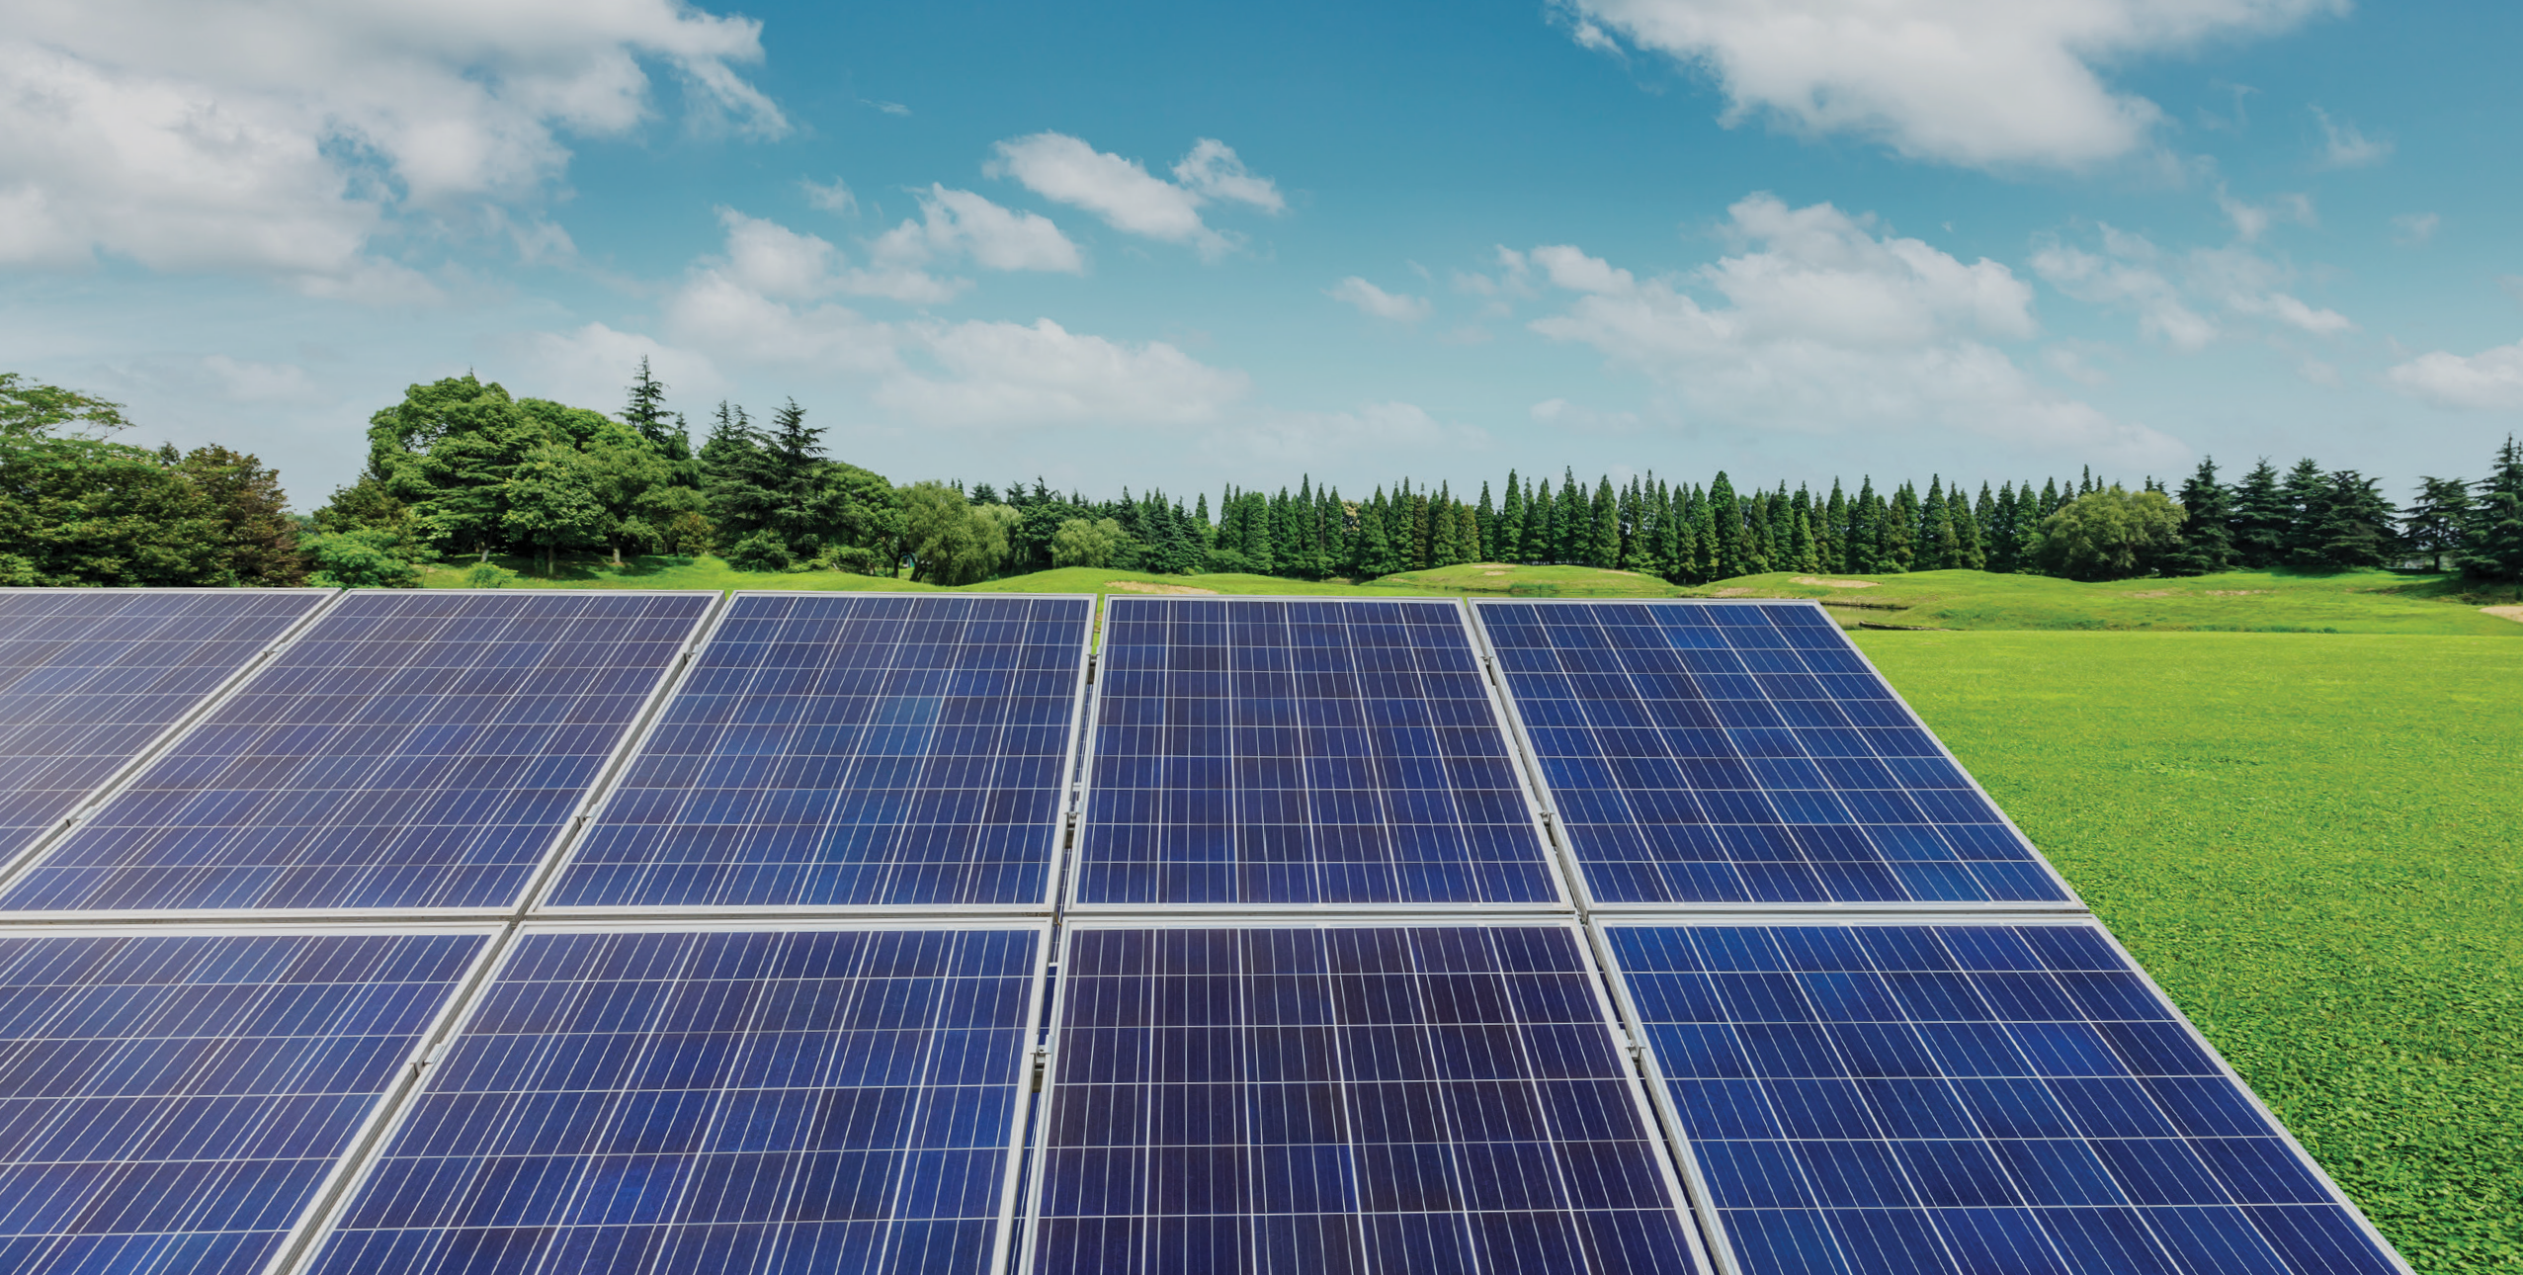

Have your say...
Proposed development of Nairn BESS,
Land at Blackpark Farm, Nairn, Highland, IV12 5HY
Anesco is committed to engaging with the local community and therefore would like to hear your views on our proposals for the Nairn Energy Storage development. Closing date 24th October 2024.
- Are you from the local area?
Yes/ No

2. Do you support the increased reliance on renewable energy as part of Scotland’s transition to a low-carbon economy?
Yes/ No / Partially/ Not Sure

3. What challenges do you foresee?
Please let us know your comments:

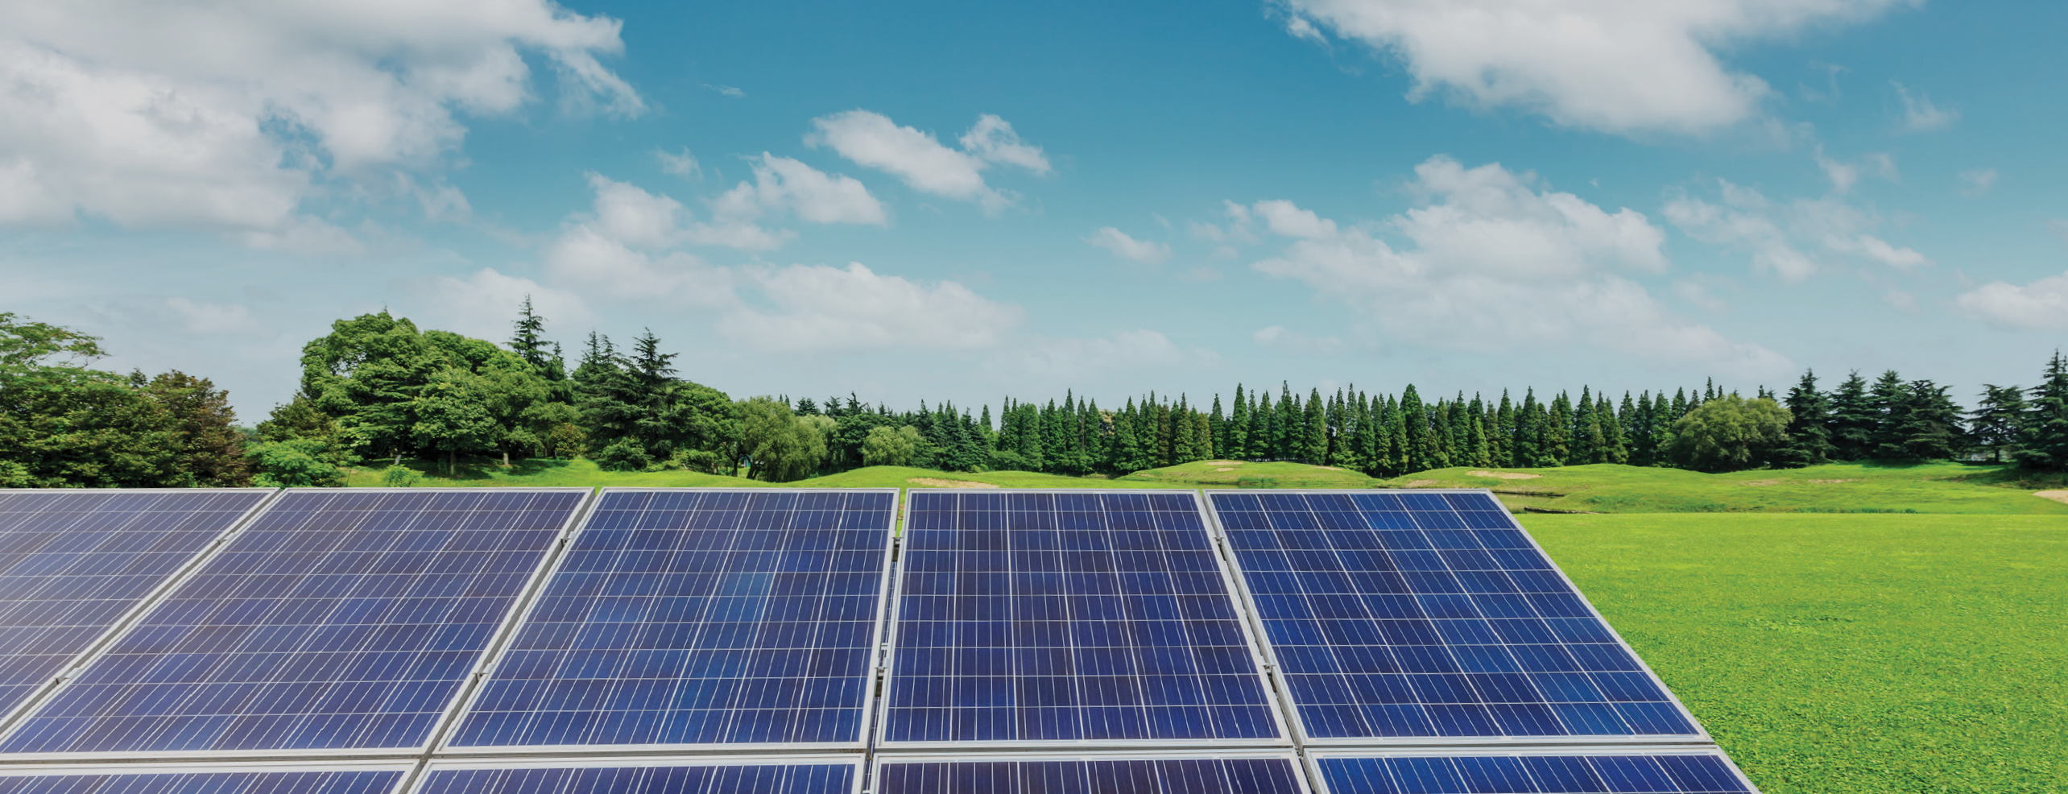

Have your say...
Proposed development of Nairn BESS,
Land at Blackpark Farm, Nairn, Highland, IV12 5HY

4. Please tick/circle the statement that most accurately reflects your views.
I/We fully support the Nairn ESS development
I/We broadly support the Nairn ESS development
I/We do not support the Nairn ESS development
I/We are undecided in the support of Nairn ESS development

5. Any other comments?

About you
Please feel free to fill in the following details and where possible, we will seek to keep you informed of any future public consultation events regarding this site.
Title Name
Organisation (if applicable) Address (including postcode)

Email address
Data protection.
Your details will not be passed on to any other private organisation and will be used only in conjunction with this consultation.

Please return this form to us at our consultation events at Nairn Community & Arts Centre, Arts Centre,
Kings Street, Nairn, IV12 4BQ, or alternatively please feel free to email your comments to:
Murphy, Etienne <Etienne.Murphy@stantec.com>
Closing date for the return of forms and feedback is 24th October 2024.

