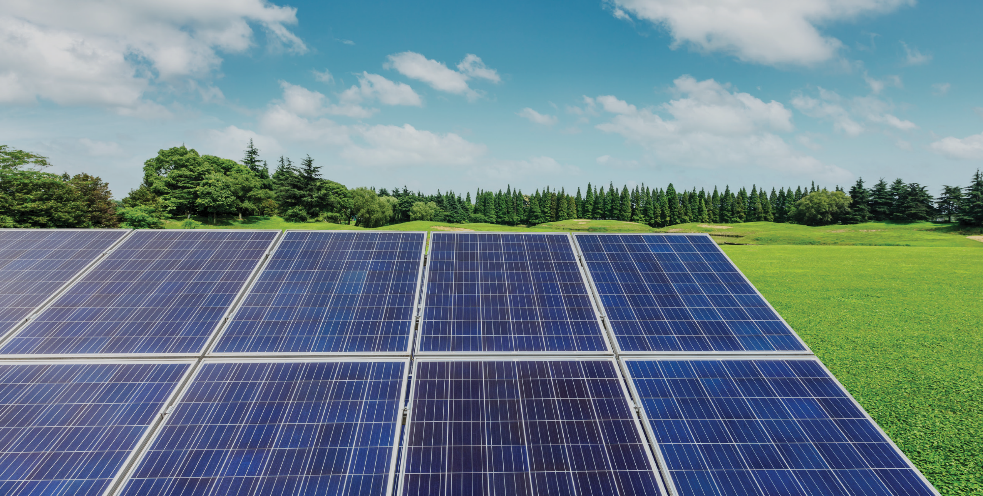

Have your say...
Proposed development of Bodymoor BESS,
Land at Bodymoor Heath Lane, Lea Marston CP, Marston, Warwickshire,
B76 0DZ.

Anesco is committed to engaging with the local community and therefore would like to hear your views on our proposals for the Bodymoor Energy Storage development.
- Are you from the local area?
Yes/ No

2. Do you support the increased reliance on renewable energy as part of the UK’s transition to a low-carbon economy?
Yes/ No / Partially/ Not Sure

3. What challenges do you foresee?
Please let us know your comments:



Have your say...
Proposed development of Bodymoor BESS,
Land at Bodymoor Heath Lane, Lea Marston CP, Marston, Warwickshire,
B76 0DZ.

4. Please tick/circle the statement that most accurately reflects your views.
I/We fully support the Bodymoor ESS development
I/We broadly support the Bodymoor ESS development
I/We do not support the Bodymoor ESS development
I/We are undecided in the support of Bodymoor ESS development

5. Any other comments?

About you
Please feel free to fill in the following details and where possible, we will seek to keep you informed of any future public consultation events regarding this site.
Title Name
Organisation (if applicable) Address (including postcode)

Email address
Data protection.
Your details will not be passed on to any other private organisation and will be used only in conjunction with this consultation.

Please return this form to us at our consultation events at Bodymoor consultation Address, or alternatively please feel free to email your comments to:
Peter Atkin <Peter.Atkin@Pegasusgroup.co.uk>
Closing date for the return of forms and feedback is ……..

